**Pro Bookstore Website**

# Mockups & Prototypes

**Version 1.0**

**03/10/2023**

**Group members:**

**1. Đàm Thị Linh**

**2. Trần Thị Hường**

**3. Nguyễn Hoàng Vỹ**

**4. Đặng Quỳnh Trang**

**5. Lại Thị Minh Trang**

**6. Nguyễn Thị Nhung Anh**

### Customer

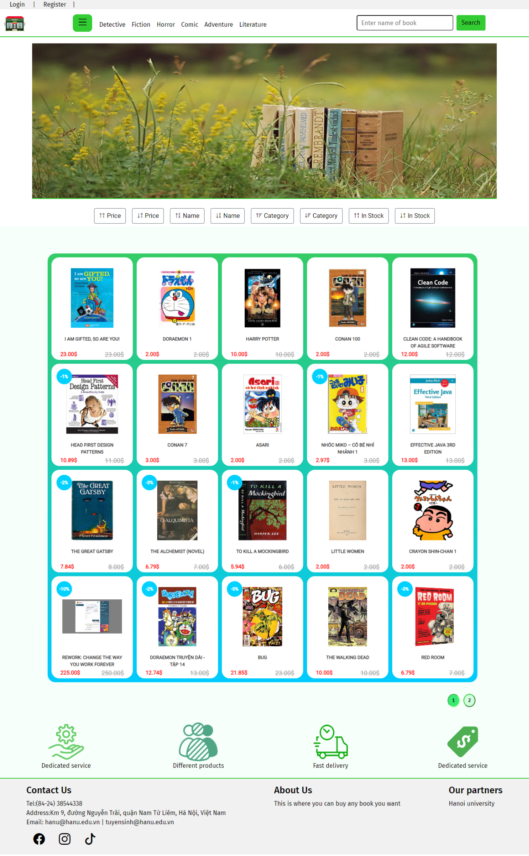

**Figure 1: Home page**

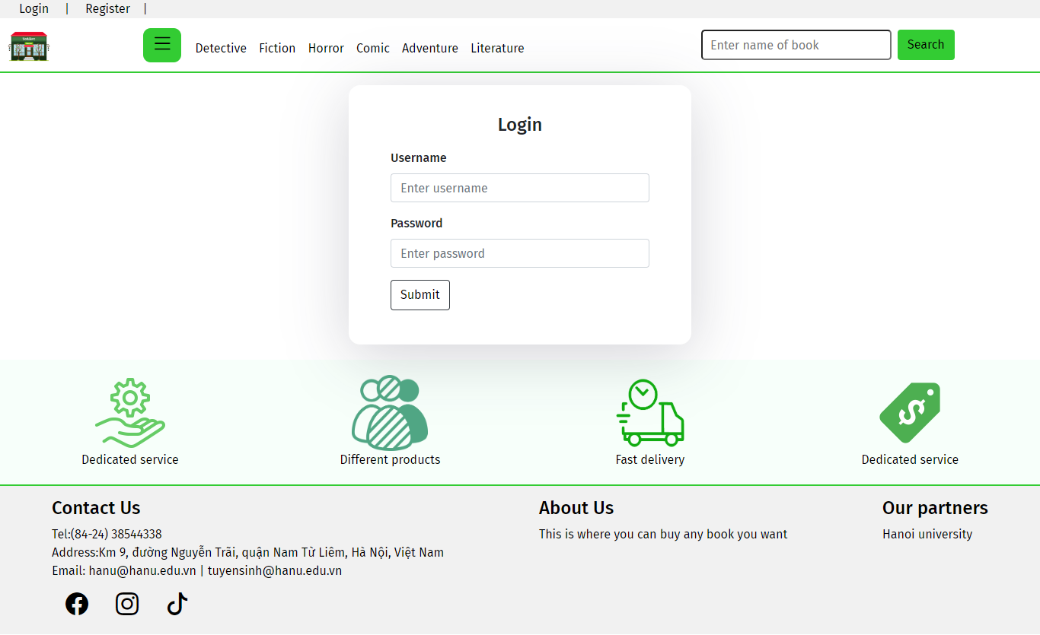

**Figure 2: Login page**

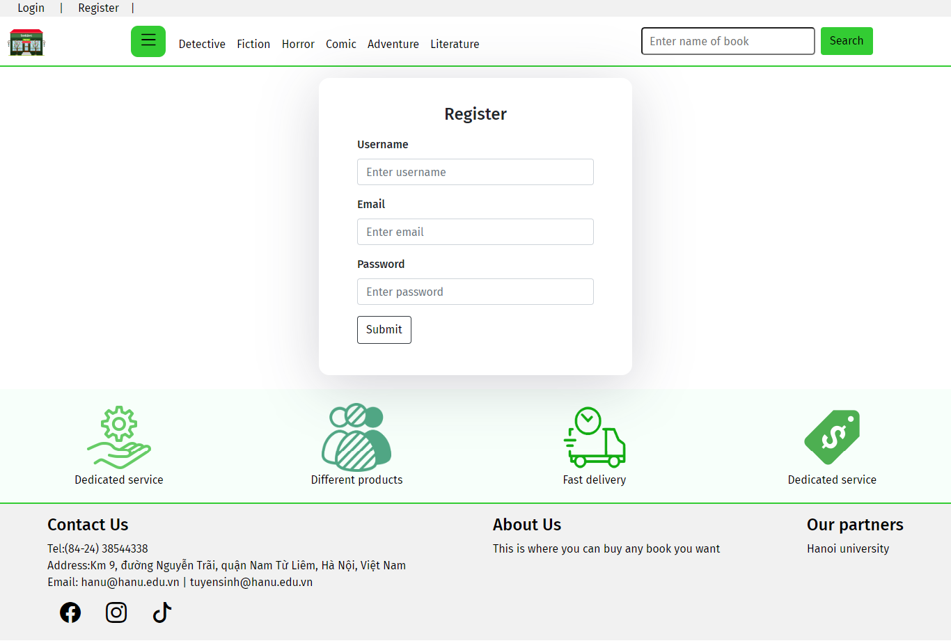

**Figure 3: Register page**

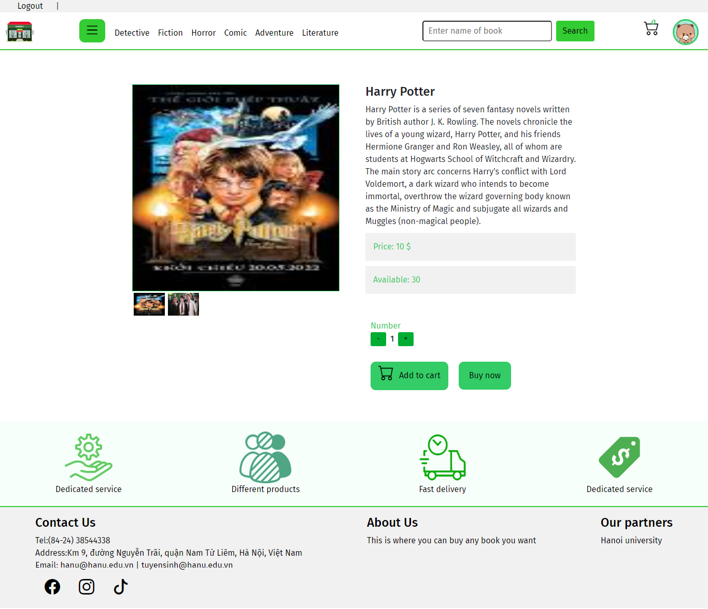

**Figure 4: Product detail page**

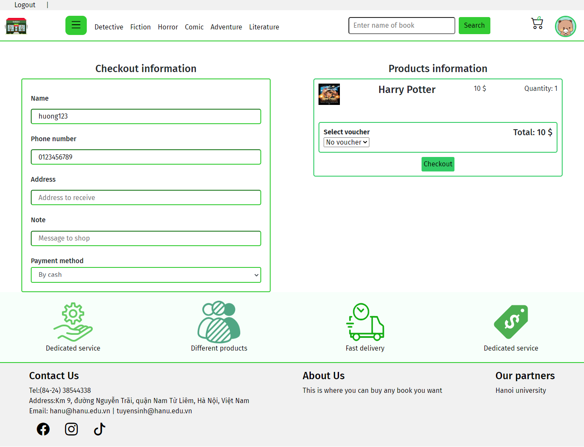

**Figure 5: Check out order page**

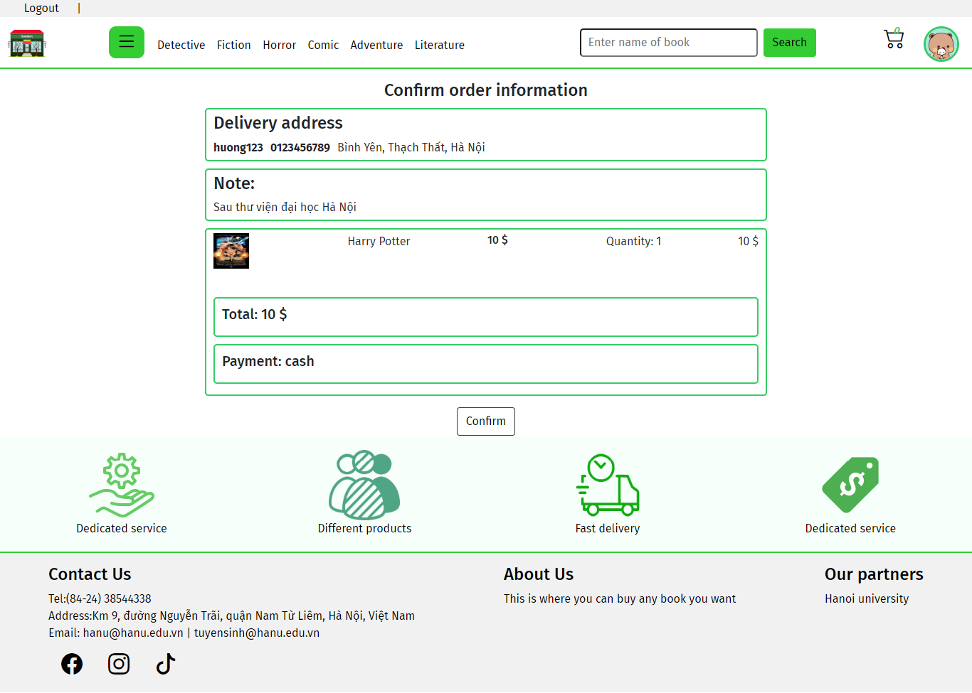

**Figure 6: Confirm order information page**

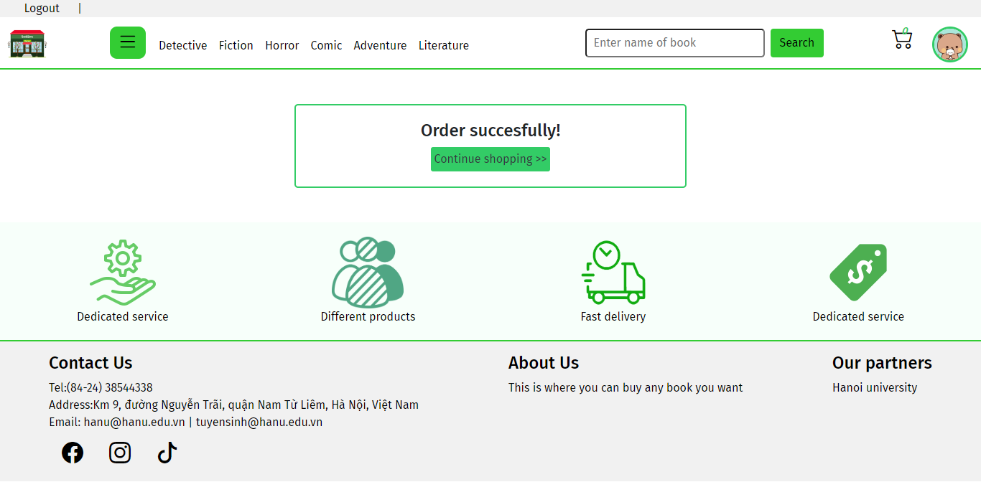

**Figure 7: Order result notification**

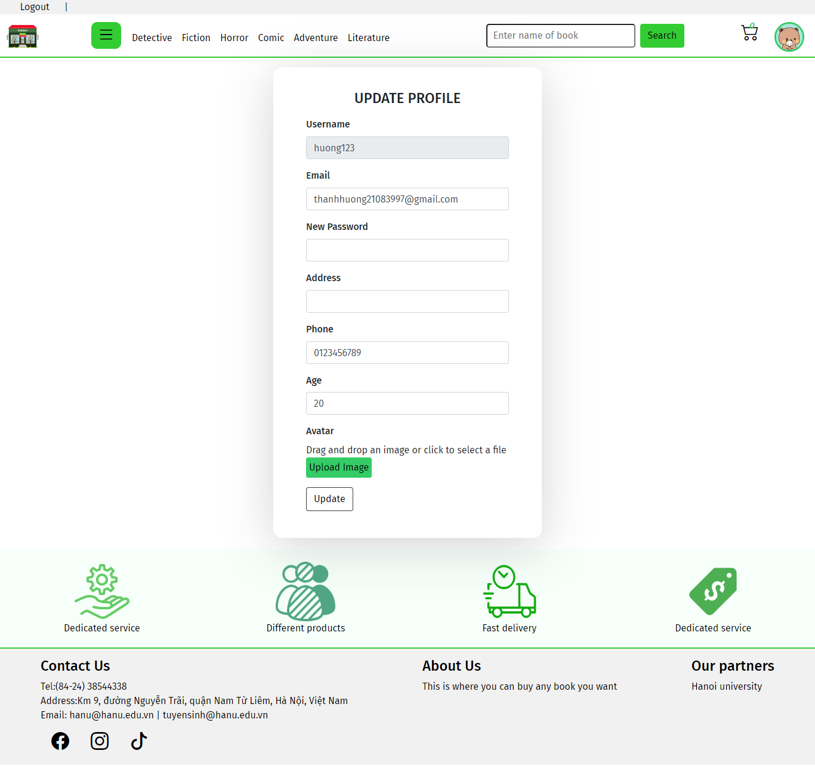

**Figure 8: Update customer profile**

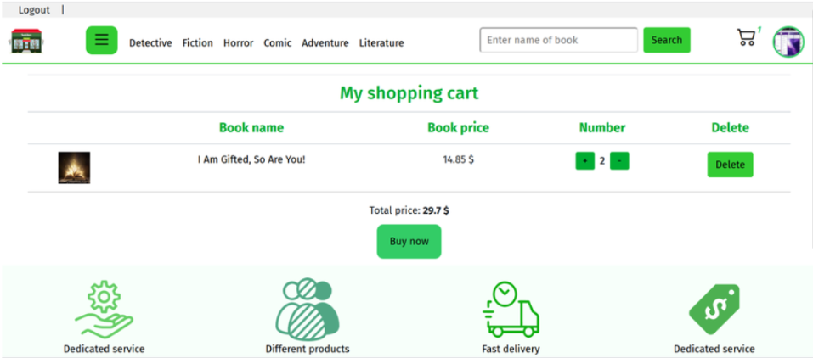

**Figure 9: Cart page**

1. **Admin**

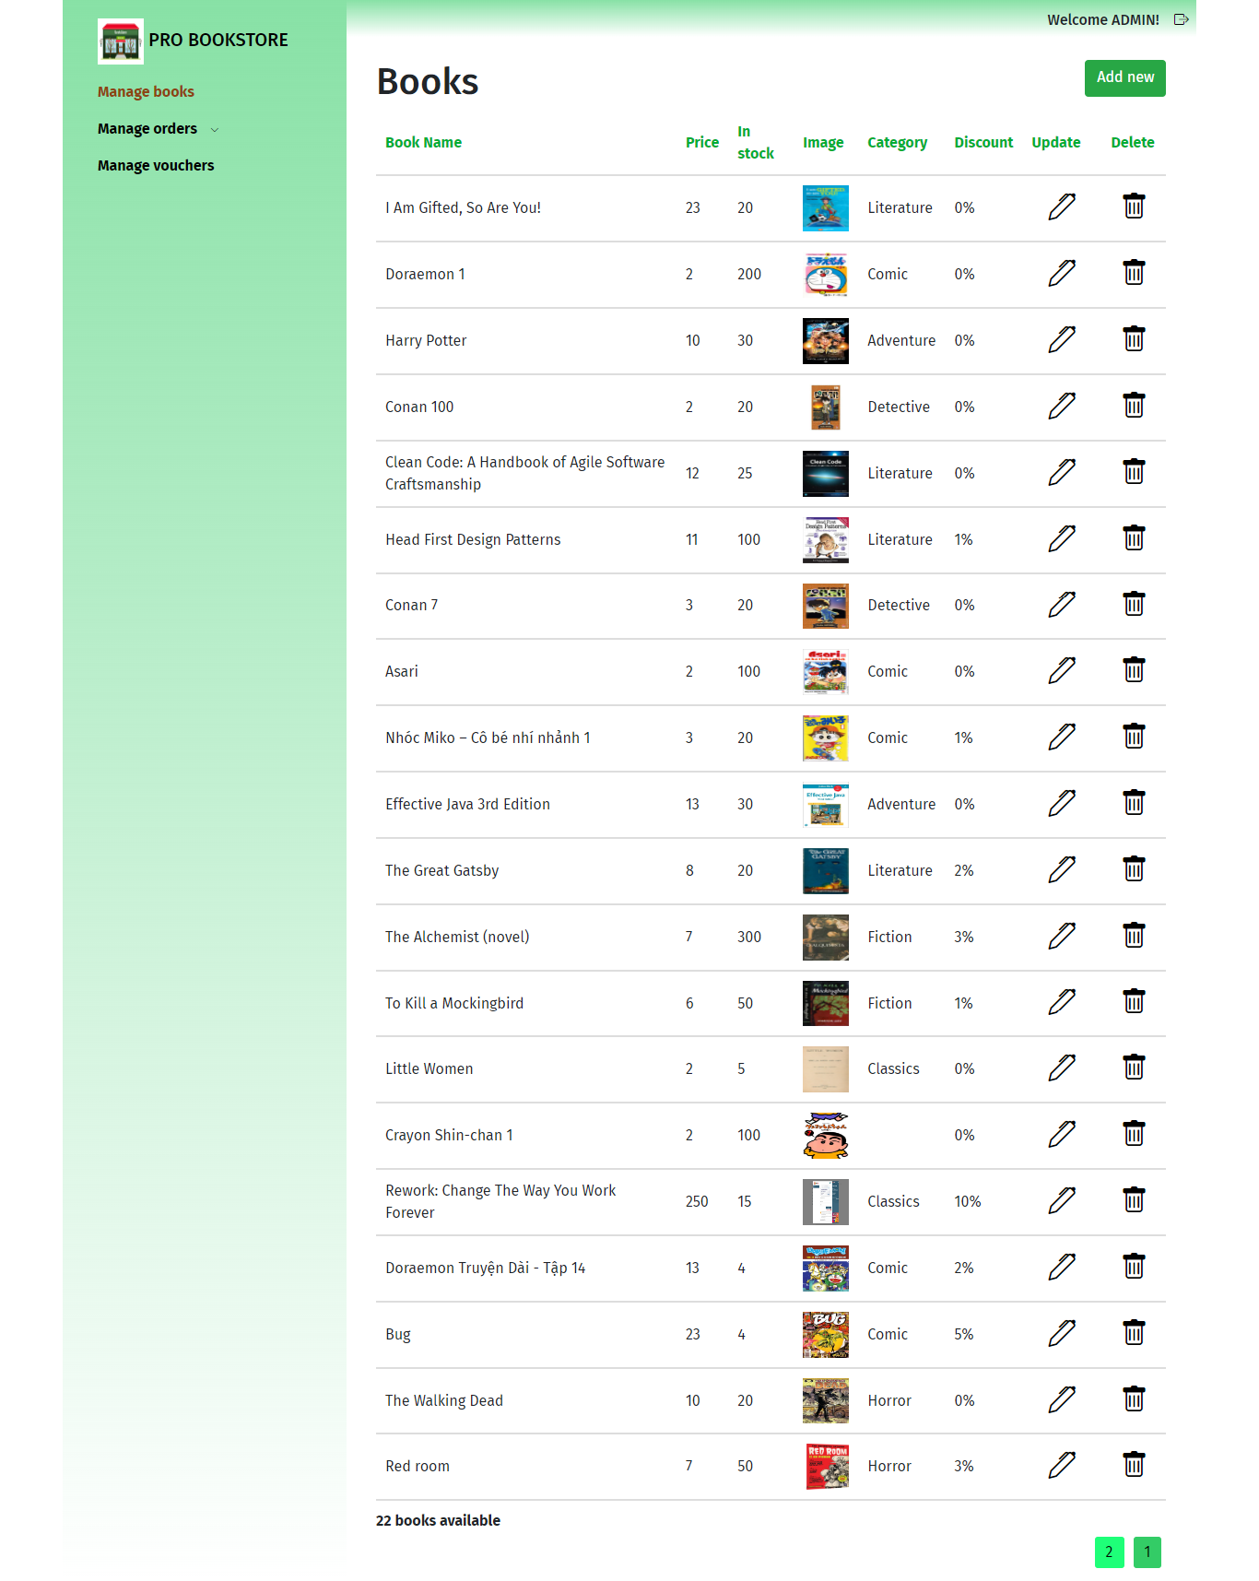

**Figure 10: Admin homepage**

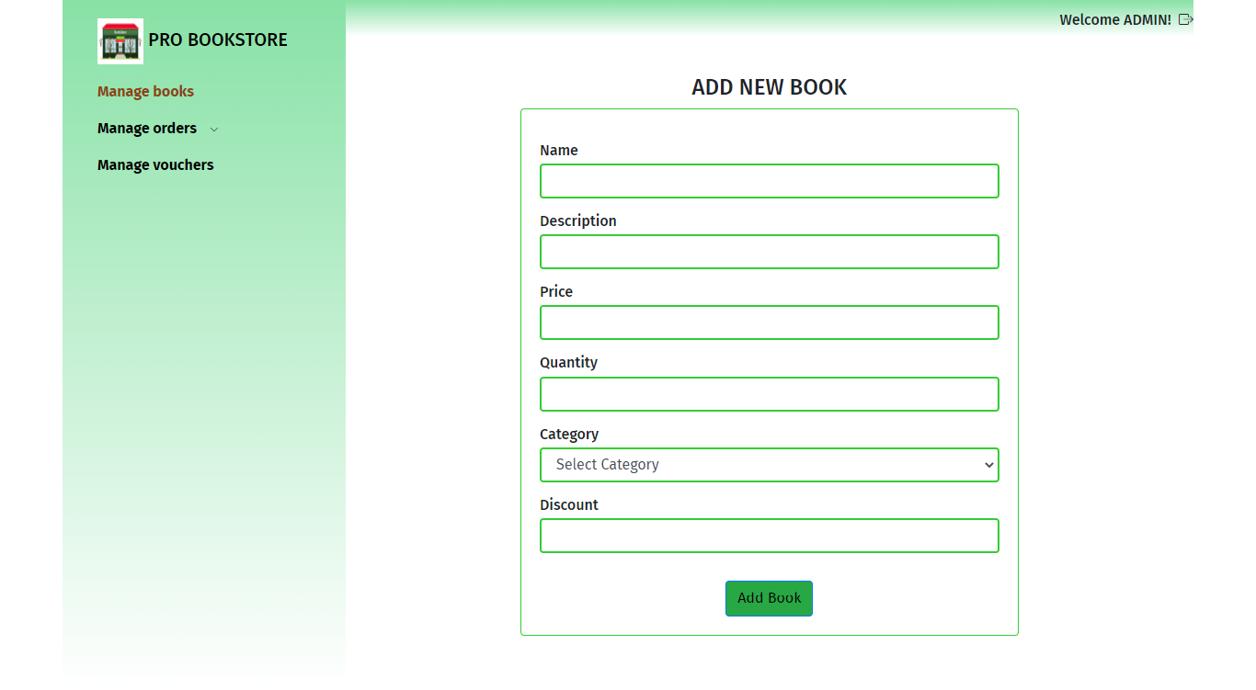

**Figure 11: Add new book**

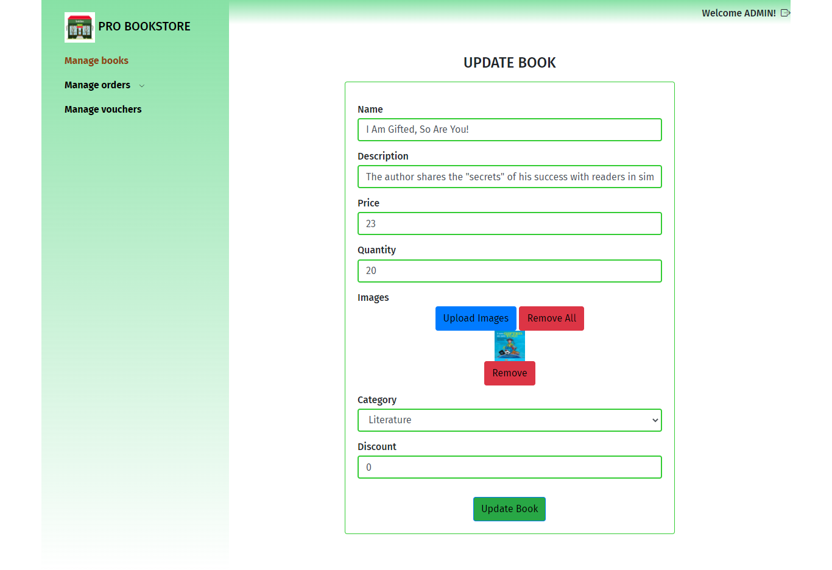

**Figure 12: Update book information**

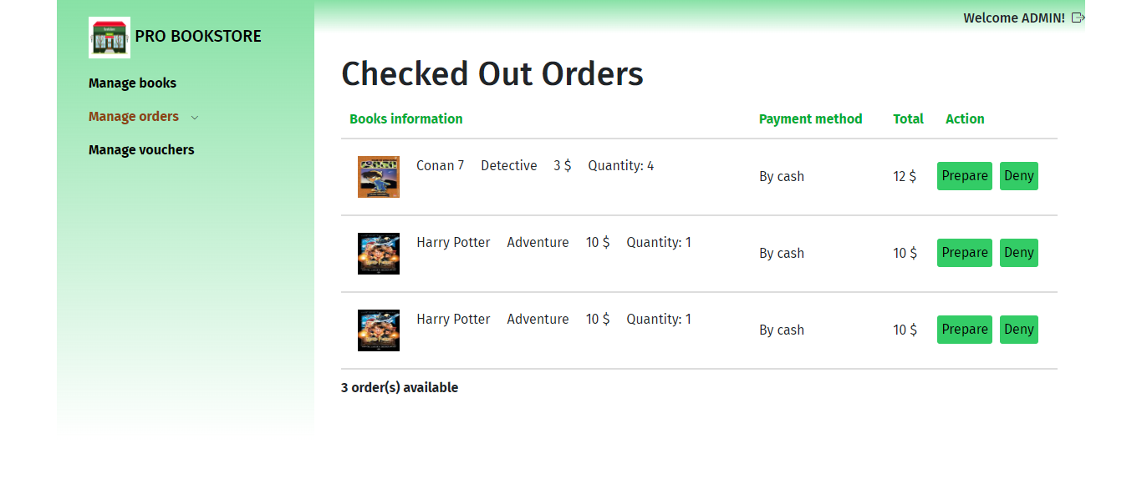

**Figure 13: Manage order page**

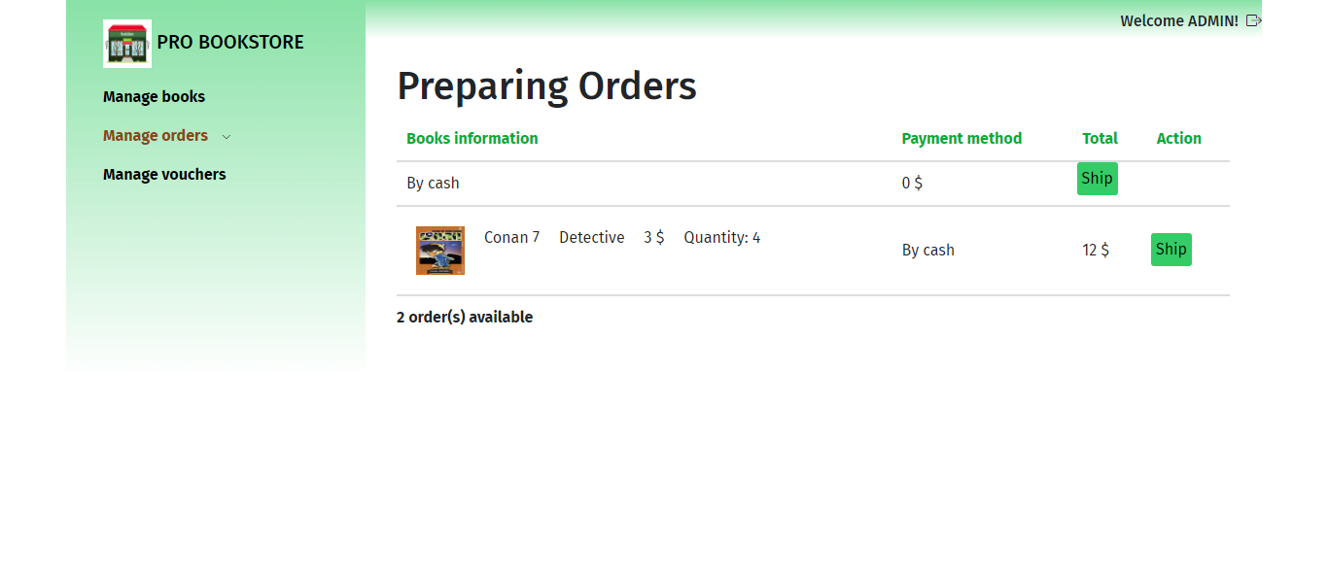

**Figure 14: Manage order page**

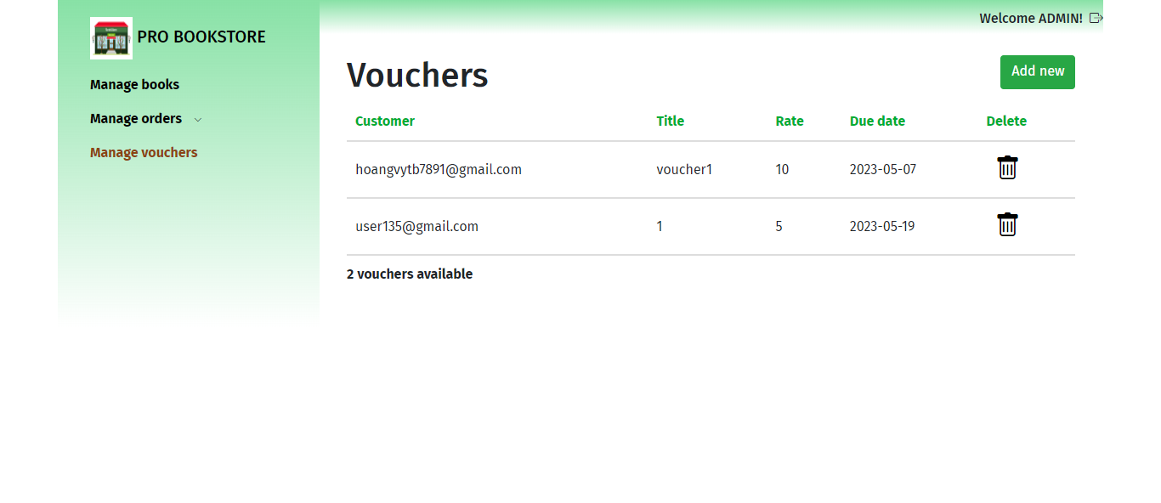

**Figure 15: Voucher list page**

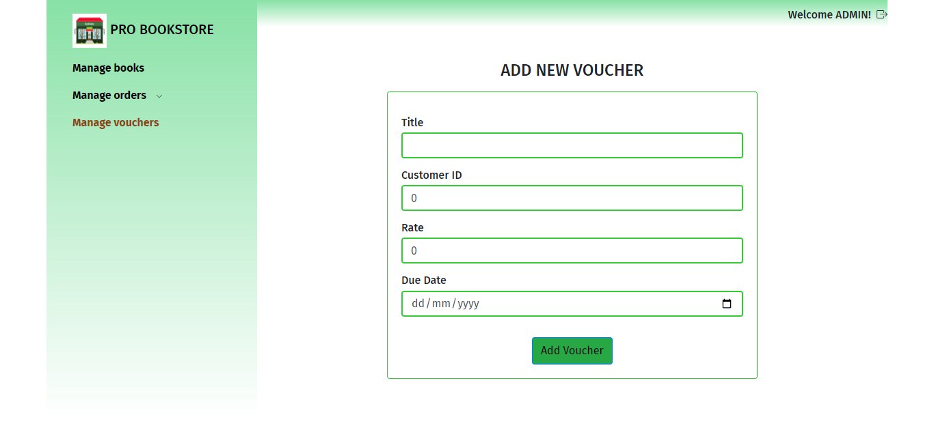

**Figure 16: Add new voucher page**